
KARNATAKA STATE COUNCIL FOR SCIENCE AND TECHNOLOGY
Indian Institute of Science campus, Bengaluru
Telephone: 080 – 23341652, 23348848 || Email: spp@kscst.org.in
Website: www.kscst.org.in/spp.html or https://kscst.karnataka.gov.in/en
FORMAT FOR STUDENT PROJECT PROPOSAL FOR THE
49th SERIES OF STUDENT PROJECT PROGRAMME
(Handwritten proposals will not be accepted, please fill all the details in this MS word file, insert images / diagrams wherever necessary. Convert to pdf file, get it approved from the project guide / head of the department and principal of your institution. Keep ready the scanned pdf file of 1) Declaration and Endorsement 2) details of processing fees made and fill-up the Google Form.
https://forms.gle/iXiR81MyoLWn871x7
Name of the College: SJC Institute of Technology

Project Title: AI-Driven EEG Diagnostic System for Non-Invasive Detection of Depression in Children and Adolescents

Branch: Artificial Intelligence and Data Science

Theme (as per KSCST poster): Healthcare Technology: Telemedicine platforms, AI for medical diagnosis, and 0wearable health monitors.
(The project proposals shall mandatorily be from one of the broad themes / areas. Visit website www.kscst.org.in/spp.html)

Name of project guide:
- Name: Mr. Badrinath K
Email id: badrik86@gmail.com
Contact No.: 9743625894
Name of Team Members (Strictly not more than four students in a batch): (Type names in Capital Letters as provided in your college)
(Please paste the latest passport size photograph adjacent to your respective names)
Name: BALAPPAGARI LATHA SREE
USN No.: 1SJ22AD006
Email id: lathasree.balappagari@gmail.com
Mobile No: 8328169670

Name: CHAGALERU SATHYANARAYANAGARI MOUNIKA
USN No.: 1SJ22AD008
Email id: mounimounika2897@gmail.com
Mobile No.: 9652590663

Name: MAREDDY CHARAN
USN No.: 1SJ22AD024
Email id: charanmareddy26@gmail.com
Mobile No.: 9704253762

Team Leader of the Project:
Name: MAREDDY CHARAN
USN No.: 1SJ22AD024
Email id: charanmareddy26@gmail.com
Mobile No.: 9704253762
Processing Fee Details (Through Online Payment only):
(processing fee of Rs. 1180/-)
Please furnish the payment details in the format provided in the last page of the proposal.
Date of commencement of the Project:
01/03/2025
Probable date of completion of the project:
01/11/2025
Timeline Structure
Task | Start Date | End Date | Duration | Milestone achievable
Project Initiation | 01/03/2025 | 31/03/2025 | 1 Month | Proposal Idea
Research Phase | 01/04/2025 | 30/04/2025 | 1 Month | Identification of problem
Development Phase | 01/05/2025 | 31/08/2025 | 4 Months | Developed the project
Testing Phase | 01/09/2025 | 30/09/2025 | 1 Month | Test case design
Submission of PPT and Abstract to KSCST for conducting mid-term evaluation  (Upload to Google Form) | Middle of March – 2nd Week of April 2026
Final Review | 01/11/2025 | 07/11/2025 | 1 Week | Successfully completed review
Project Submission | 01/12/2025 | 07/12/2025 | 1 Week | Successfully submitted project.
Submission of Project Completion Report to KSCST (Upload to Google Form) | April / May 2026

Scope / Objectives of the project:
A non-invasive EEG-based screening system is being developed to assist in identifying early signs of depression in children and adolescents. A Hybrid CNN–LSTM deep learning model is applied to interpret spatial and temporal patterns within EEG signals, providing a data-driven approach to mental state classification. The system is intended to support school counseling units, pediatric psychologists, and mental health monitoring programs by offering an additional objective tool alongside traditional clinical assessments. The scope includes EEG data collection, preprocessing to remove noise and artifacts, segmentation of brainwave signals, deep learning model training and tuning, followed by validation and performance evaluation to ensure system reliability and real-world suitability. Considerations around ethical data handling, privacy, and age-appropriate psychological interpretation are also integrated. By enabling earlier recognition of emotional disturbances, the system contributes to preventive mental healthcare, timely intervention, and improved emotional and academic well-being among young individuals.
Methodology:
EEG data is obtained from children and adolescents using non-invasive scalp electrode placements following standard EEG acquisition protocols. The recorded signals undergo systematic preprocessing to enhance data quality, including band-pass filtering for noise reduction, Independent Component Analysis (ICA) for artifact removal, normalization for amplitude consistency, and segmentation into time-windowed frames to preserve temporal sequence information. The preprocessed EEG segments are then provided as input to a Hybrid CNN–LSTM deep learning architecture, where the CNN component extracts spatial and frequency-based features from the brainwave patterns, and the LSTM component models the temporal dependencies and neural activity transitions over time. The output of the LSTM layers is passed through fully connected layers and a Softmax classifier to categorize mental states as either Normal or Depressed. The system’s effectiveness is evaluated using performance metrics such as Accuracy, Precision, Recall, F1-Score, and Confusion Matrix, ensuring model reliability and diagnostic relevance. This structured methodology supports the development of a robust and data-driven screening system suitable for early mental health assessment in educational and clinical environments.
Note: In case of fabrication work in the project, an engineering drawing with dimensions / detailed design should be attached to the proposal.
Expected Outcome of the project:
A reliable non-invasive EEG-based mental health screening system is expected to be developed, capable of distinguishing between normal and depressive neural patterns in children and adolescents. The Hybrid CNN–LSTM model is anticipated to provide accurate and consistent classification by effectively capturing both spatial and temporal features present in EEG signals. The outcome includes a trained and validated deep learning model along with an easy-to-use interface that can assist school counselors, child psychologists, and healthcare professionals in early detection and monitoring of depressive symptoms. By enabling timely identification, the system aims to support preventive mental health strategies, reduce psychological risk progression, and promote emotional well-being and healthy academic development among young individuals. The final result is expected to serve as a supplementary decision-support tool, complementing professional clinical assessment while ensuring ethical, child-friendly, and practical application in real-world educational and pediatric healthcare settings.
Is the project proposed relevant to the Industry / Society or Institution?
Yes / No: Yes
If yes, please provide details of the industry / institution and contact details:
The project holds strong relevance to society, educational environments, and healthcare practice. Depression and emotional stress among children and adolescents are increasing due to academic pressure, social influences, and changing lifestyles. Early detection and timely support are essential to prevent long-term psychological and behavioral challenges. The AI-driven EEG screening system being developed provides a non-invasive, objective, and data-driven approach for identifying depressive tendencies at an early stage.
The system can be effectively utilized in school counseling and wellness centers, pediatric mental health clinics, and child psychology departments, supporting professionals such as counselors, psychologists, and psychiatrists in evidence-based decision-making. Organizations such as NIMHANS, Bangalore (National Institute of Mental Health and Neurosciences), educational institutions with structured student wellness programs, and pediatric behavioral health centers may act as valuable collaborators for system validation and practical deployment.
Overall, this system strengthens early mental health monitoring efforts, enhances access to psychological support, promotes emotional well-being, and reduces long-term developmental risks, thereby proving its meaningful value to industry, society, and institutional mental health initiatives.

(Note: Preference will be given to those projects relevant to the industry / institution. Hence be specific in giving detailed information). Is the industry extending support - technology / funds / use the final product, please specify.
Can the product or process to be developed in the project be taken up for filing a Patent?
Yes / No: Yes
At the current stage, the product can be considered for patent filing as it introduces potential novelty in combining EEG-based depression detection with an optimized CNN–LSTM architecture, customized preprocessing techniques, and possible real-time analysis integration. If further validated and refined, this approach could demonstrate innovative value in mental health assessment and non-invasive diagnostic support systems, making it eligible for intellectual property protection.
Prior Art search done?
Yes/No: Yes
A preliminary Prior Art Search has been conducted to review existing patents and research related to EEG-based depression detection systems. The search indicates limited overlap with the proposed implementation approach, supporting the potential for novelty and patent consideration upon further development and validation.
Note: If your answer is “Yes”, you may contact Patent Information Centre of KSCST. For more details, email: pic@kscst.org.in
Budget details (break-up details should be given):
Note: KSCST will provide nominal grant support for carrying out the project by students if selected by the project selection committee.
Budget | Amount
a) Materials / Consumables (Please specify) | 4000.00
b) Labor (Describe) | 1500.00
c) Travel (Describe) | 2000.00
e) Miscellaneous (Please specify) | 1500.00
Total | 9000.00

Any other technical details (Please specify):
A Hybrid Convolutional Neural Network (CNN) and Long Short-Term Memory (LSTM) architecture is employed to enable comprehensive analysis of EEG signals, where CNN layers extract spatial and frequency-related features, while LSTM layers capture temporal dependencies and sequential brainwave variations. EEG data undergoes systematic preprocessing, including noise reduction, normalization, artifact removal, and window-based segmentation, to ensure high-quality and meaningful signal input for model training.

Model performance is assessed using standard evaluation metrics such as Accuracy, Precision, Recall, F1-Score, and Confusion Matrix to ensure robustness, reliability, and consistency of classification outputs. The implementation is performed in Python, utilizing frameworks such as TensorFlow/Keras for deep learning model development and NumPy, SciPy, and MNE for EEG-specific data processing and signal handling.

Ethical guidelines are considered throughout the development process, particularly due to involvement with minors; therefore, the system is intended strictly as an assistive decision-support tool rather than a standalone diagnostic replacement. The final model is envisioned to be deployable within school counseling environments, pediatric psychological centers, and mental health support units through an accessible desktop or web-based screening interface, enabling early monitoring and timely intervention.

SPP Coordinator (Identified by the college):
Note: To be identified by the principal of the institution. The project proposals must be submitted to KSCST through SPP coordinator designated by the principal.

Name: Mrs. :E.N.Srivani
Email id: srivani1598.ece@sjcit.ac.in
Contact No.: 8639902870

(Name & Signature of  SPP Coordinator with Seal) | Name and signature of the  Project Guide with Seal:
Email id: srivani1598.ece@sjcit.ac.in | Email id: badrik86@gmail.com
Contact No.: 8639902870 | Contact No.: 9743625894

DECLARATION
(From Project Students)
(To scan this page and enclose in the project proposal)

We, the project team hereby declare that the details enclosed in the project proposal (Title of the Project: AI-Driven EEG Diagnostic System for Non-Invasive Detection of Depression in Children and Adolescents, Branch: Artificial Intelligence and Data Science, College: SJC Institute of Technology) are true and correct to the best of our knowledge and belief. We undertake to inform the Karnataka State Council for Science and Technology (KSCST) of any changes to the project title or team members' names immediately through our project guide or the SPP Coordinator of our institution.
Additionally, we declare that the project work is original and not a result of copying or purchasing. We are committed to completing the project independently, with support from our faculty and project guide, while utilizing the facilities provided by the college. We will not engage in plagiarism and pledge to be sincere and dedicated in executing and completing the project as proposed.
We understand that if any of the above information is found to be false, untrue, or misleading, we may be held liable. We authorize the sharing of the project information contained in this proposal with KSCST, Bengaluru.
We acknowledge that the project team must exhibit and demonstrate the project, participate in the mid-term evaluation of sanctioned projects, and engage with experts. Additionally, we must exhibit the project at the Annual State-Level Poster Presentation and Exhibition, if selected. Should our team fail to participate in the mid-term evaluation or the Annual Exhibition (if selected), we understand that the supported project funds will be returned to KSCST.
We also enclose the endorsement form for KSCST, Bengaluru.
Name of the students with USN No. Signature with date
- BALAPPAGARI LATHA SREE(1SJ22AD006)
- CHAGALERU SATHYANARAYANAGARI(1SJ22AD008)
- MAREDDY CHARAN(1SJ22AD024)

(Name & Signature of  SPP Coordinator with Seal) | Name and signature of the  Project Guide with Seal:
Email id: srivani1598.ece@sjcit.ac.in | Email id: badrik86@gmail.com
Contact No.: 8639902870 | Contact No.: 9743625894

ENDORSEMENT
(From College, endorsement to be taken in the institution / Department Letter head)
(To scan this page and enclose in the project proposal)

This is to certify that 1) Ms. Balappagari Latha Sree, 2) Ms. Chagaleru Sathyanarayanagari Mounika 3) Mr. Mareddy Charan, are bonafide student(s) of Department of Artificial Intelligence and Data Science, in the degree program of our institution. If the project proposal submitted by these students under the 49th series of Student Project Programme is selected by KSCST, we will provide the requisite laboratory / Computer / infrastructure support in our college / Institution. Further we also take necessary steps to see that the project team will exhibit / demonstrate their project in the mid-term evaluation of project and in the Annual State-Level Poster Presentation and Exhibition (if selected). If the student team fails to send the completed project report or fails to attend the evaluation in mid-term evaluation of sanctioned projects or fails to attend the Annual State-Level Poster Presentation and Exhibition (if selected), the supported project amount will be returned to KSCST.
(Name & Signature of  Project Guide with Seal) | (Name & Signature of  SPP Coordinator with Seal) | (Signature of HoD  with Seal)
Email id: badrik86@gmail.com | Email id: srivani1598.ece@sjcit.ac.in | Email id: hodaids@sjcit.ac.in
Contact No.: 9743625894 | Contact No.: 8639902870 | Contact No.: 9972925814
 |  | (Signature of the Principal with Seal)
 |  | Email id: principal@sjcit.ac.in
 |  | Contact No.: 08156-220184

DETAILS OF PROCESSING FEES MADE THROUGH
NEFT / UPI PAYMENT
(Note: Include this page in the softcopy of the student project proposal. The student team shall furnish the details in the Google Form. It is informed to the students to 1) keep ready the softcopy of the project proposal and other documents and 2) Furnish the payment made details as processing fees and 3) update the details in the Google Form on the same day of payment made to KSCST by NEFT / UPI payment).
For finance related queries, please contact KSCST accounts section: 080 – 23341652, 23348848, email: finance@kscst.org.in
- TITLE OF THE PROJECT | : | AI-Driven EEG Diagnostic System for Non-Invasive Detection of Depression in Children and Adolescents
- NAME OF THE TEAM LEADER | : | MAREDDY CHARAN
- EMAIL ID | : | charanmareddy26@gmail.com
- CONTACT MOBILE NO. | : | 9704253762
PAYMENT MADE DETAILS
- BANK REF. NO. / UTR NO. / UPI No. (12 digits) | : | 804654973763
- TRANSACTION ID | : | T2511141518192151705827
- NAME OF THE SENDER / ACCOUNT HOLDER and CONTACT NUMBER | : | Mareddy Charan  9704253762
- NAME OF THE BANK | : | State Bank of India
- PROCESSING FEES | : | Rs. 1,180/- (Inclusive of 18% GST)
- DATE OF PAYMENT MADE | : | 14/11/2025
- TIME | : | 3:18 Pm
- MODE OF PAYMENT MADE  (NEFT / UPI, PLEASE SPECIFY) | : | Online UPI

(Name & Signature of  the team leader) | (Name & Signature of  Project Guide / SPP Co-ordinator / HOD  with Seal)
KARNATAKA STATE COUNCIL FOR SCIENCE AND TECHNOLOGY
Indian Institute of Science campus, Bengaluru
49th SERIES OF STUDENT PROJECT PROGRAMME (SPP)
(Note: This page is for information about bank details of KSCST to the student team and college / institution and not to include this page in the project proposal softcopy)

BANK ACCOUNT DETAILS OF KSCST
Name and address of the Institution | Karnataka State Council for Science and Technology, IISc Campus, Bangalore -560012
Account holder’s name / Designation | Secretary, Karnataka State Council for Science and Technology
Bank Account No. & Name of the bank | Current A/C No. 0683201000024  Canara Bank, IISc Campus Branch, Bangalore-560012
IFSC Code | CNRB0000683
MICR Code | 560015023
Bank Branch Address | Canara Bank, Indian Institute of Science, Bangalore-560012

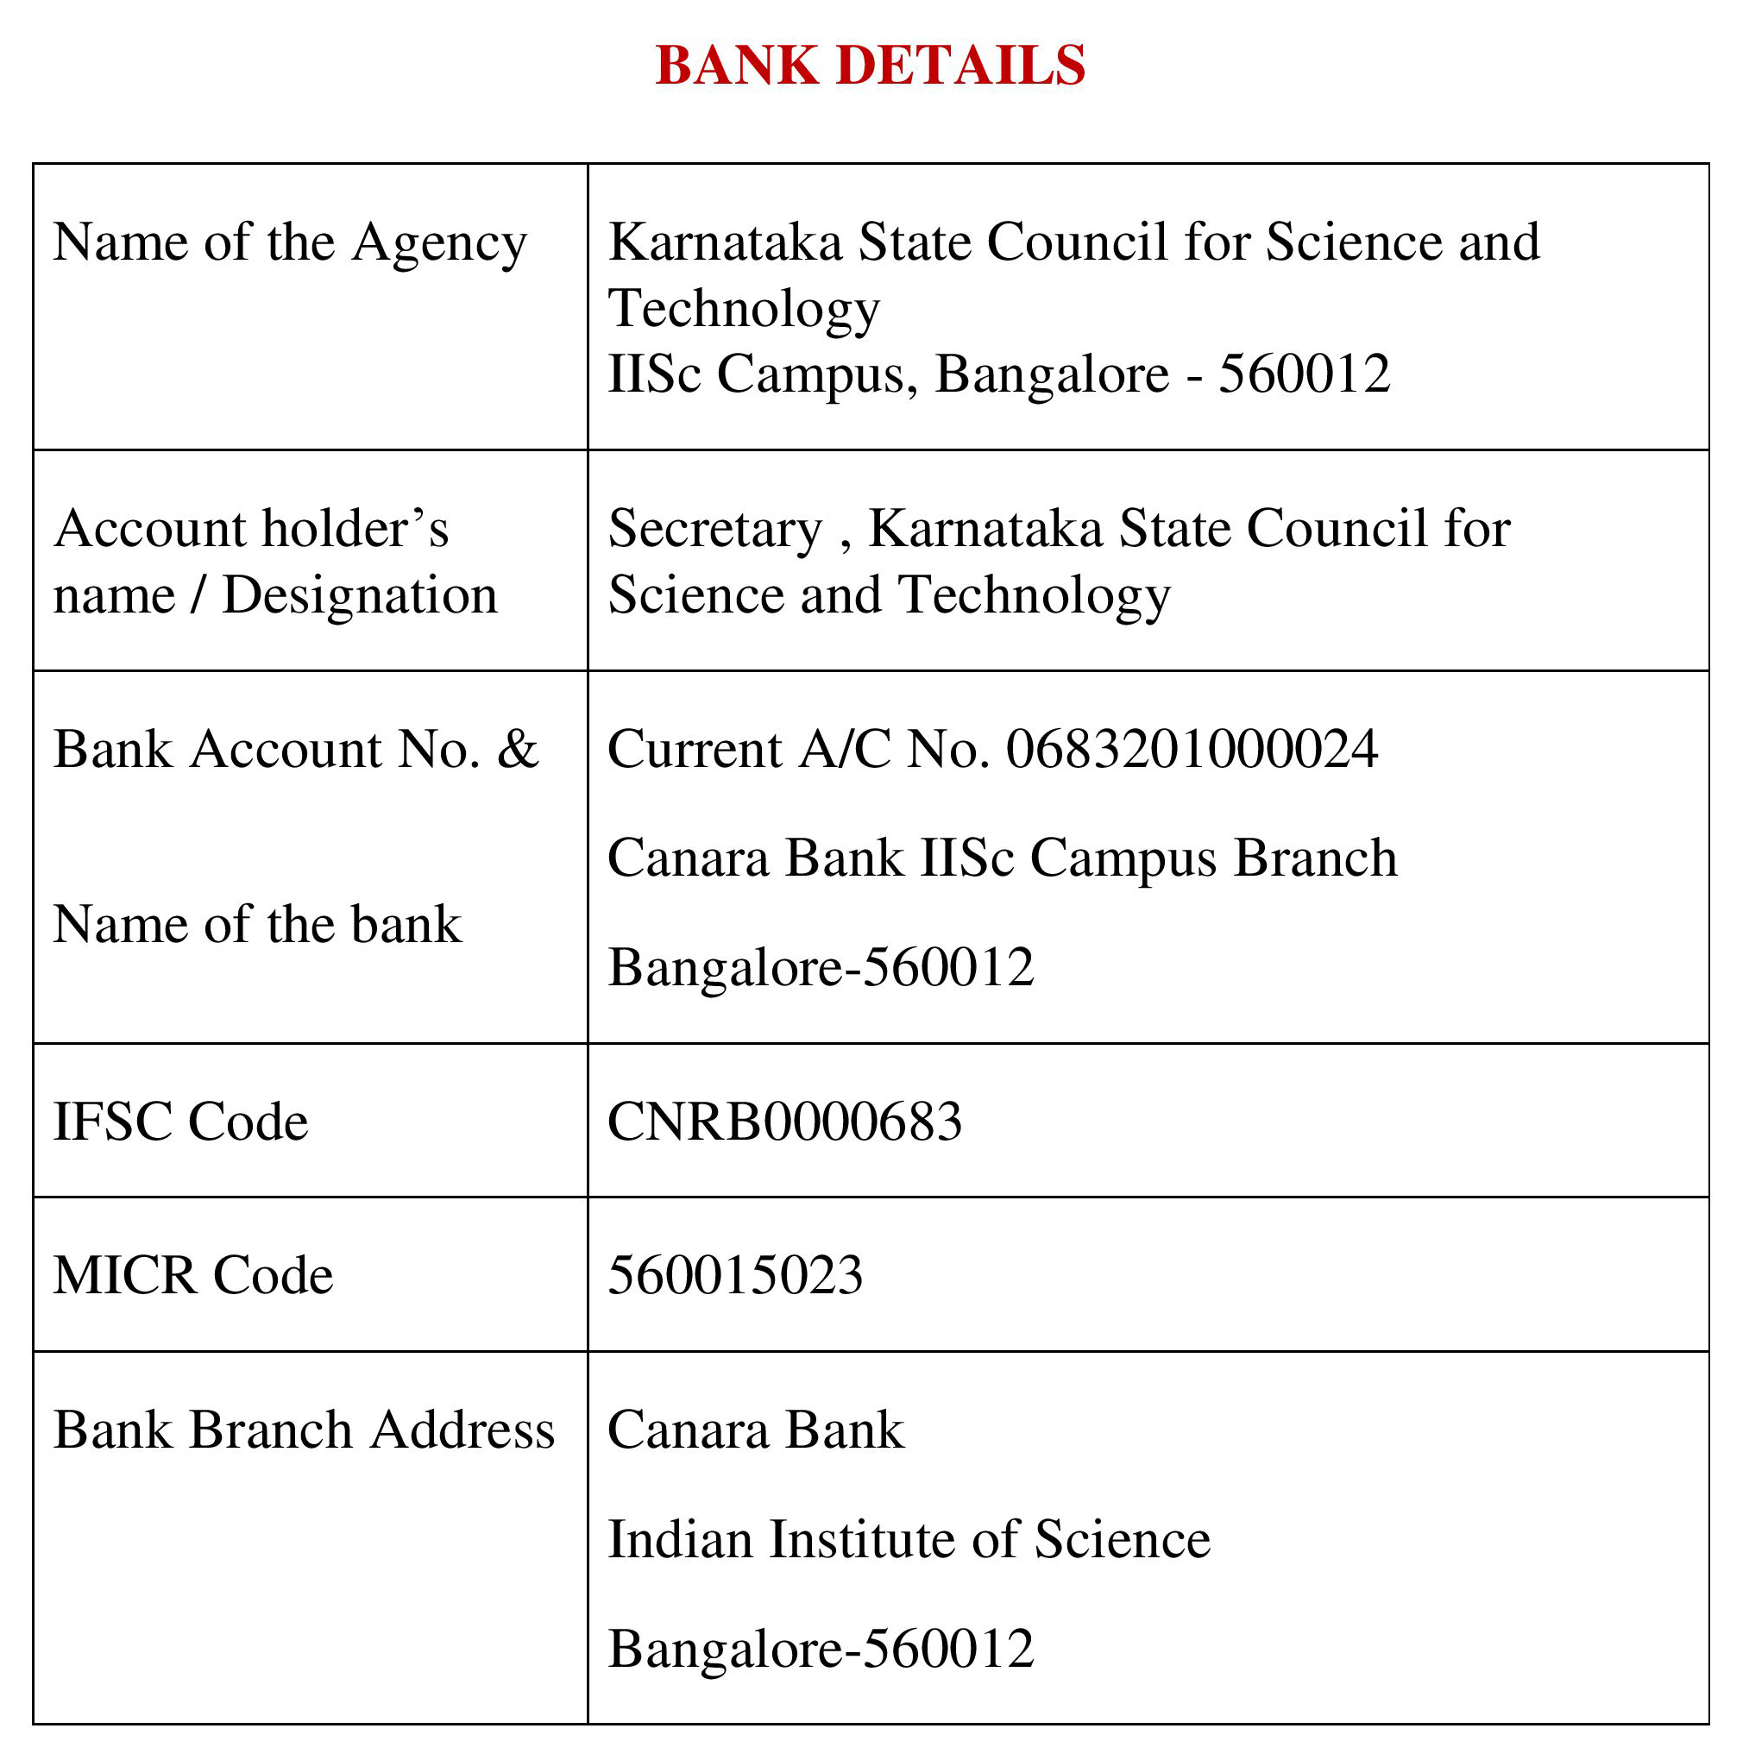
Note: For finance related queries, please contact KSCST accounts section: 080 – 23341652, 23348848 during office hours between 3.00 pm to 5 pm, email: finance@kscst.org.in with a copy to spp@kscst.org.in
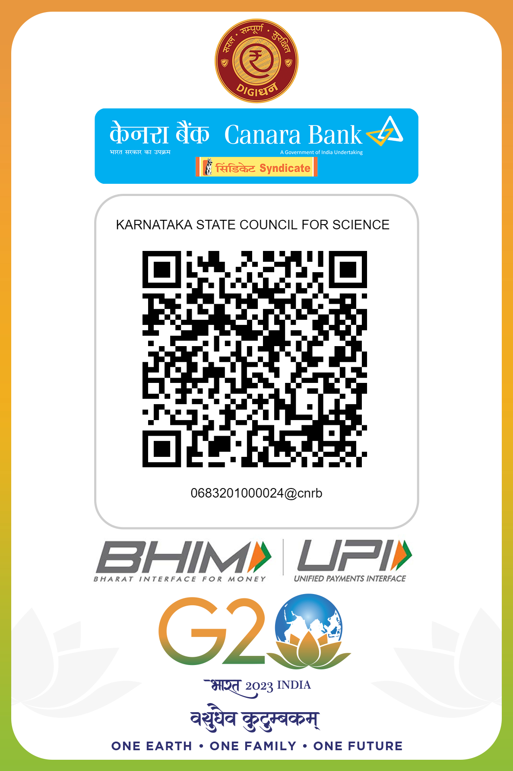
Note: For finance related queries, please contact KSCST accounts section: 080 – 23341652, 23348848 during office hours between 3.00 pm to 5 pm, email: finance@kscst.org.in with a copy to spp@kscst.org.in

